Instruction to Authors: How to Submit an Article in Cognitive Engineering (an ISTE Open Science journal)  **[Style: *ISTE – Titre francais]**

Instruction to Authors: How to Submit an Article in Cognitive Engineering (an ISTE Open Science journal) **[Style: *ISTE – English title]**

First name-1 Surname-11, First name-2 Surname-22, First name-3 Compound-noun-33, Double-barrel first name-4 Surname-4, Name-Initial-55, Double-barrel surname-55 **[Style : *ISTE - Authors]**

1 Laboratoire Alpha, EA-487, Université de Paris, France, email-1@email.mail **[Style : *ISTE - Affiliations]**  
2 Institute of Beta and Gamma, Hangzhou, China, email-2@email.com  
3 Département de cognition numérique, Ecole Nationale d’Informatique, Faa, French Polynesia, email3@email3.eu  
4 School of Medical Science, Vincennes, University Max Twain of Indiana, Indiana, USA, email4@email4.edu

5 Centre de recherche sur la Pensée Complexe, UMR-121, CNRS, Université de Caen, France, email5@email5.fr

**ABSTRACT.** **[*ISTE – Abstract/title key words]**  
The instructions put together below fall into four categories. The publisher would be grateful to authors for respecting these indications. The length of this summary may attain a dozen lines. It is to be written in size Arial 9, spacing 13 points. An abstract in French will be joined. **[*ISTE – Abstract/text key words]**

**KEYWORDS.** **[*ISTE – Abstract/title key words]**  
Maximum of 10 significant keywords, in English, will be separated by a comma, as key words, and listed in alphabetical order. **[*ISTE – Abstract/text key words]**

1. First level head [*ISTE – 1. level head]

1.1. Second level head [*ISTE – 1.1. level head]

This paragraph is a classic paragraph. This paragraph is a classic paragraph. This paragraph is a classic paragraph. This paragraph is a classic paragraph. This paragraph is a classic paragraph. This paragraph is a classic paragraph. This paragraph is a classic paragraph. This paragraph is a classic paragraph. This paragraph is a classic paragraph. This paragraph is a classic paragraph. This paragraph is a classic paragraph. This paragraph is a classic paragraph. This paragraph is a classic paragraph. **[*ISTE - Paragraph]**

This paragraph is an unindented paragraph to be used for quotations or text excerpts. This paragraph is an unindented paragraph. This paragraph is an unindented paragraph. This paragraph is an unindented paragraph. This paragraph is an unindented paragraph. This paragraph is an unindented paragraph. This paragraph is an unindented paragraph. This paragraph is an unindented paragraph. This paragraph is an unindented paragraph. **[*ISTE - Paragraph no indent*]**

1.1.1. Third level head **[*ISTE – 1.1.1. level head]**

Classic paragraph. Classic paragraph. Classic paragraph. Classic paragraph. Classic paragraph. Classic paragraph. Classic paragraph. Classic paragraph. Classic paragraph. Classic paragraph. Classic paragraph. Classic paragraph. Classic paragraph. Classic paragraph. Classic paragraph. Classic paragraph. Classic paragraph. Classic paragraph. Classic paragraph. Classic paragraph. Classic paragraph. Classic paragraph.

1.2. Presentation of figures

Here is how to present figures: use the style “**\*ISTE – Figure**” for the figure itself. Use the styles “**\*ISTE - Caption**” and “**\*ISTE - Caption (Figure no ital)**” for the caption.

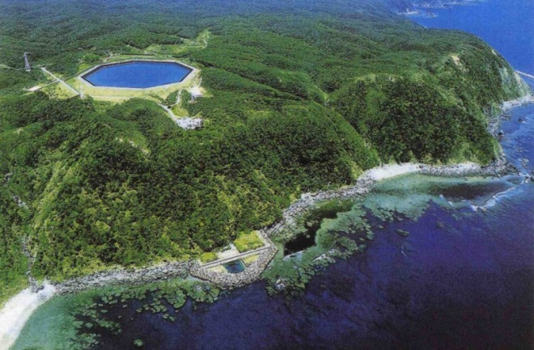

**[Style: *ISTE - Caption]**

**[Style: *ISTE – Caption (Figure no ital)**

**[Style: *ISTE - Figure]**

**Figure 1.1.** Figure caption

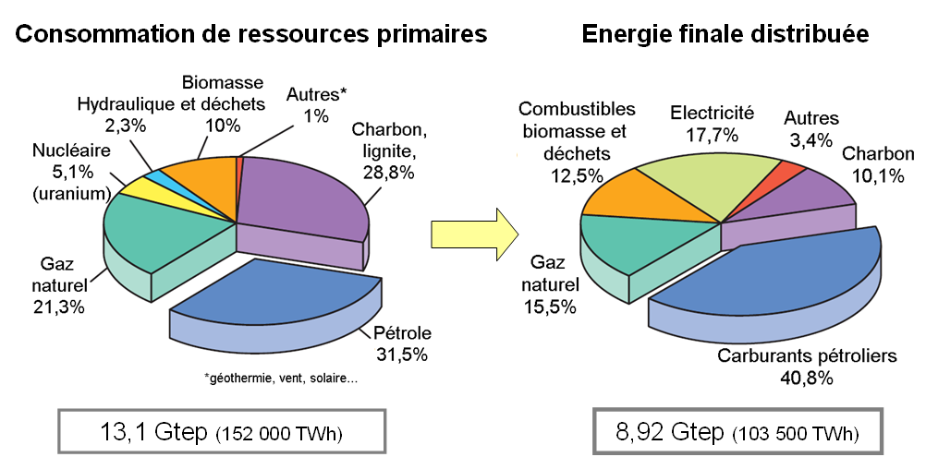

**Figure 1.2.** Figures have a maximum width of 12 cm.   
The size must allow good readability of the text

This paragraph is a classic paragraph. This paragraph is a classic paragraph. This paragraph is a classic paragraph. This paragraph is a classic paragraph. This paragraph is a classic paragraph. This paragraph is a classic paragraph. This paragraph is a classic paragraph. This paragraph is a classic paragraph. This paragraph is a classic paragraph. This paragraph is a classic paragraph. This paragraph is a classic paragraph. This paragraph is a classic paragraph. This paragraph is a classic paragraph. This paragraph is a classic paragraph. **[*ISTE - Paragraph]**

1.3. Presentation of tables

Here is how to present a table. To make it easier, you can use this table template and modify it according to your needs. The styles that can be used are “**\*ISTE - Table Head**” for the first line and first column. Then, “**\*ISTE - Table a (Normal**)”, “**\*ISTE - Table b (Center**)”, “**\*ISTE - Table c (Justify**)”, depending on the placement you want to use for the text in the gray boxes: normal, centered or justified.

Use the following styles for the caption “**\*ISTE - Caption**” and “**\*ISTE - Caption (Table no ital)**”.

|  |  |  |  |
| --- | --- | --- | --- |
|  | Normal | Centered | Justified |
| Example | Normal | Centered | Here is how the text behaves when "Justify" is selected. To be used according to the aesthetic result. Here it would be better to use "Normal" because there is a lot of text. |
| Test | Normal | Centered | Here is how the text behaves when “Justify” *is not* selected. To be used according to the aesthetic result. Here it would be better to use "Normal" because there is a lot of text. |

**Table 4.1.** Table caption

2. First level subheading [*ISTE – 1. level head]

2.1. Second level subheading [*ISTE – 1.1. level head]

Classic paragraph. Classic paragraph. Classic paragraph. Classic paragraph. Classic paragraph. Classic paragraph. Classic paragraph. Classic paragraph. Classic paragraph. Classic paragraph. Classic paragraph. Classic paragraph. Classic paragraph. Classic paragraph.

2.1.1. Second level head [**\*ISTE – 1.1.1. level head**]

2.1.1.1. Third level head [**\*ISTE – 1.1.1.1. level head**]

Classic paragraph. Classic paragraph. Classic paragraph. Classic paragraph. Classic paragraph. Classic paragraph. Classic paragraph. Classic paragraph. Classic paragraph. Classic paragraph. Classic paragraph. Classic paragraph. Classic paragraph. Classic paragraph. Classic paragraph. Classic paragraph. Classic paragraph. Classic paragraph. Classic paragraph. Classic paragraph. Classic paragraph. Classic paragraph. Classic paragraph. Classic paragraph.

2.2. Highlighting

Some important words can be highlighted in blue in the text (be careful not to use excessively so as not to interfere with reading) **[*ISTE – Blue text]**

Here are the styles to use for notes or other important paragraphs. Use sparingly so as not to impede the visual aspect of the book:

Note. **[*ISTE - Remarque bleu]** Here are the two styles to use for a note or a very important paragraph. **[*ISTE - Remarque (ou special)]**

Classic paragraph. Classic paragraph. Classic paragraph. Classic paragraph. Classic paragraph. Classic paragraph. Classic paragraph. Classic paragraph. Classic paragraph. Classic paragraph. Classic paragraph. Classic paragraph. Classic paragraph. Classic paragraph. Classic paragraph. Classic paragraph. Classic paragraph. Classic paragraph. Classic paragraph. Classic paragraph. Classic paragraph. Classic paragraph. Classic paragraph. Classic paragraph.

2.3. Unindented paragraph for citations, theorems, definitions, etc.

Here is the style to use for theorems, corollaries, definitions, lemmas, properties, texts with full or partial citations, etc. **[*ISTE - Paragraph no indent]**

The text can be italicized.

Théorem.– *This is a theorem. This is a theorem. This is a theorem. This is a theorem. This is a theorem. This is a theorem*.  **[*ISTE - paragraph no indent]**

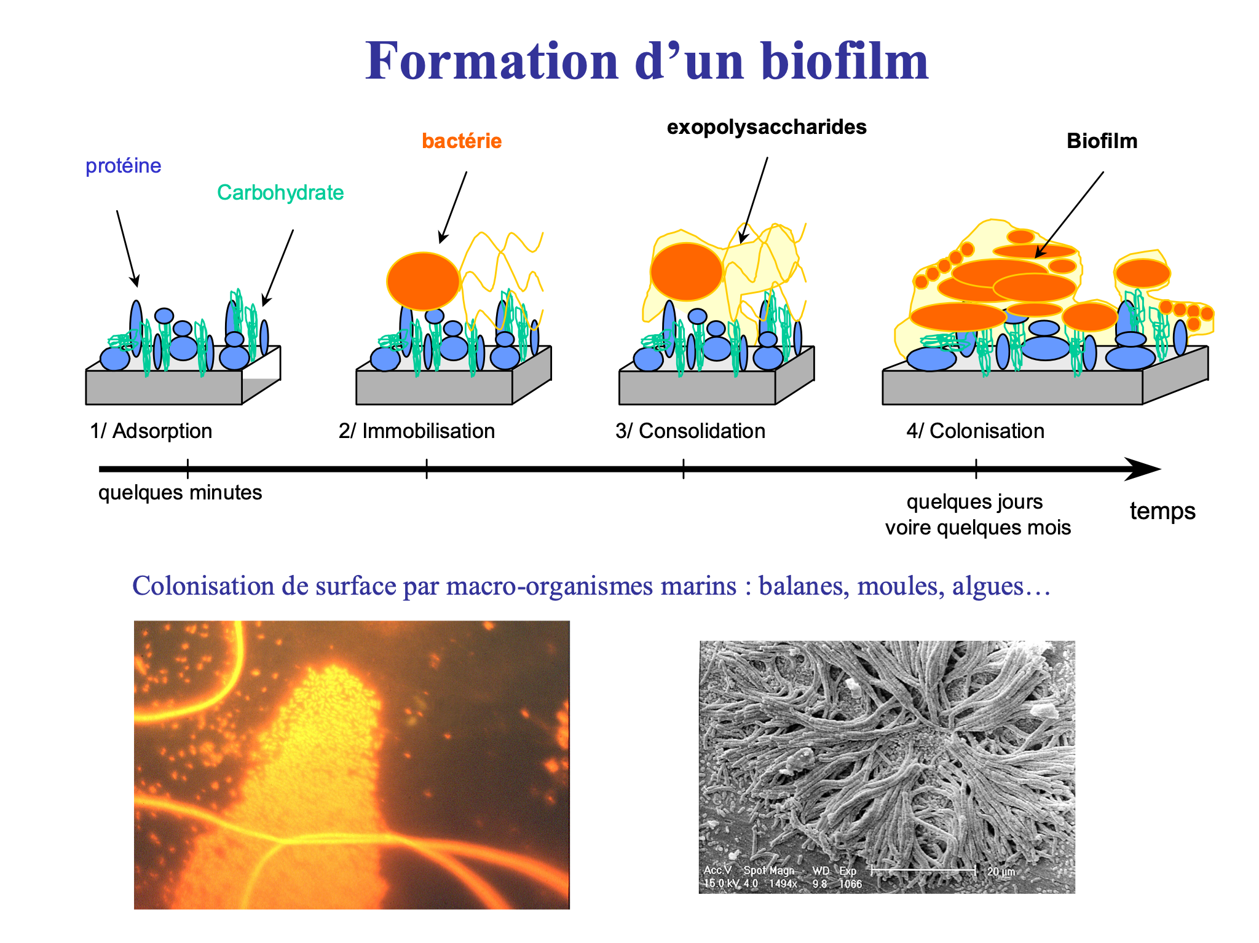

**Figure 4.3.** Figure caption

3.1. Lists

This paragraph introduces a list: **[*ISTE - Paragraph before a list]**

list list list list; **[*ISTE - List (except last line)]**

* list list list list.  **[*ISTE - List (last line)]**

Important.  Important paragraph. Important paragraph. Important paragraph. Important paragraph. Important paragraph. Important paragraph. Important paragraph. Important paragraph. Important paragraph. Important paragraph. **[*ISTE* - Remarque Blue + *ISTE* - Remarque (or special)]**

3.2. Boxes

Here is how to present boxes: style "*ISTE - Box".

For the caption, use the style “*ISTE – Caption” and “*ISTE – Caption (Box no ital)”.

**Level head in a box [*ISTE - Box]**

Boxes must be in style **[*ISTE - Box]**. Boxes must be in style Box. Boxes must be in style Box. Boxes must be in style Box. Boxes must be in style Box. Boxes must be in style Box. Boxes must be in style Box. Boxes must be in style Box. Boxes must be in style Box. Boxes must be in style Box. Boxes must be in style Box.

Boxes must be in style Box. Boxes must be in style Box. Boxes must be in style Box. Boxes must be in style Box. Boxes must be in style Box. Boxes must be in style Box. Boxes must be in style Box. Boxes must be in style Box. Boxes must be in style Box. Boxes must be in style Box. Boxes must be in style Box.

**Box 4.1.** Box caption

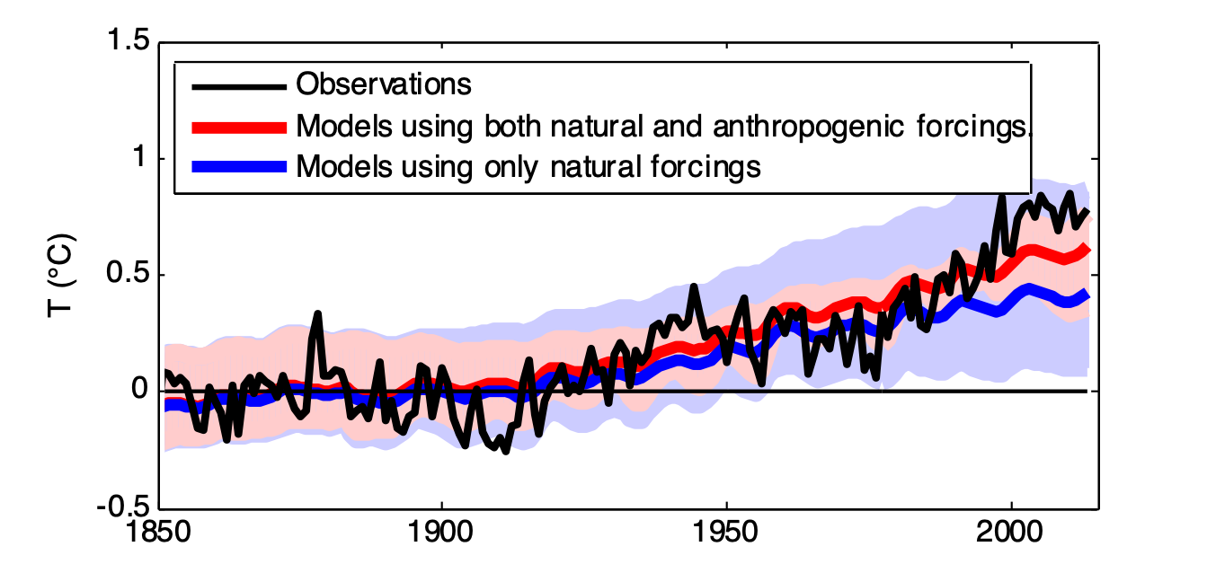

**Figure 4.4.** Figure caption

4.4. Reminder about equations

4.4.1. Style to be used

Equations are always introduced by “:”.

The style to be used is: “*ISTE - Equation”

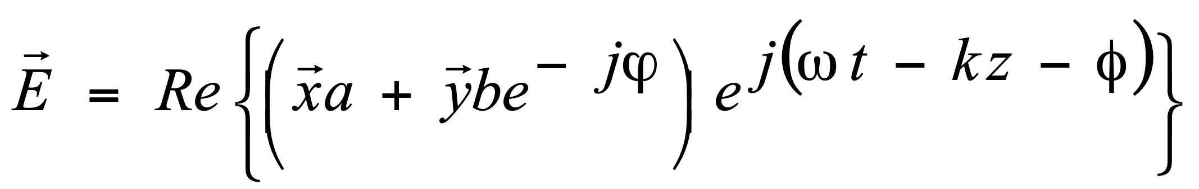 [1] **[Style: *ISTE - Equation]**

4.4.2. Equation numbering

Equations are numbered according to their order of appearance:

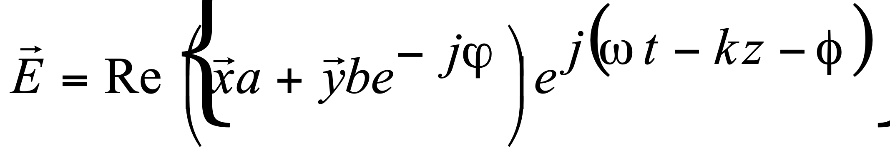 [2]

 [3]

4.5. Citations

4.5.1. Style to be used

Citations can be provided in an off-paragraph style with shifted left and right margins and in speech marks. The style to be used is “**\*ISTE - Large quotes/extracts**”:

“Here is an example of a citation. Here is an example of a citation. Here is an example of a citation. Here is an example of a citation. Here is an example of a citation. Here is an example of a citation. Here is an example of a citation. Here is an example of a citation. ” (Author, book, date) **[Style: *ISTE – Large quotes/extracts]**

5. Bibliography

The bibliography comes at the end of the article. Particular attention is requested from authors in the drafting of the bibliography. There is no reference in the bibliographic list without reference in the text, and vice versa.

Two styles are used:

- style: **“*ISTE – Bibliographie bleu”** to put the author reference in square brackets in blue.

- style: **“*ISTE - Bibliography”** for the rest of the reference.

In the text, each reference is introduced by three letters followed by the last two digits of the year of publication, all in square brackets: [ABC 12] for (Abcart A., Becart B., Cecart C., 2012). For multiple references, we use a, b, etc. According to the alphabetical order of the following letters: [ABC 12a] for (Abcart A., Becart B., 2012) and [ABC 12b] for (Abcart A., Zecart Z., 2012) and so on.

In the final bibliography, the references are introduced by the same information as in the text, for example [BEL 94] Belarbi A., Hsu T.-T.-C., etc.

Author names are in “small caps” form: Belisle C., Linard M. Each author's name is directly followed by his or her initials. No commas are to be used between surnames and first name initials. The initials of the first names are followed by a full stop: C.

The list of authors finishes with a comma.

Article titles are to be between speech marks, book titles, newspaper titles, journal titles and proceedings are to be in italics.

The names of editors are to be followed with a commas and place of publication (possibly with a specified state for the USA, Canada, etc.).

[BEL 94] **[*ISTE* - Bibliography Blue]** Belarbi A., Hsu T.-T.-C., “Constitutive laws of concrete in tension and reinforcing bars stiffened by concrete”, *ACI Structural Journal*, title 91-S46, p. 465-474, July/August 1994. **[*ISTE* - Bibliography entries]**

[BEL 96] Belisle C., Linard M., “Quelles nouvelles compétences des acteurs de la formation dans le contexte des TIC ?”, *Education Permanente*, n° 127, p. 19-47, 1996.

[BOU 02] Bouhaï N., *Lire, réécrire et partager le savoir sur le web : problèmes et solutions*, PhD thesis, Université de Paris VIII Saint Denis, 2002.

[CHE 14] Chen K., *Evaluation de performances par simulation et analyse : applications aux réseaux informatiques*, ISTE Editions, London, 2014.

[CHE 14] Chetto M., *Ordonnancement dans les systèmes temps réel*, ISTE Editions, London, 2014.

[FAV 98] Favre B., *Les transports durables*, ISTE Editions, London, 2014.

[HAC 14] Hachour H., Szoniecky S., Abouad S., “Espaces sémio-cognitifs : les frontières des systèmes de recommandation”, in G. Kembellec, G. Chartron, I. Saleh (eds.), *Les moteurs de recommandation*, ISTE Editions, London, 2014.

[LEM 14] Lemaire M., *Mécanique et incertain*, ISTE Editions, London, 2014.

[MON 14a] Monaco A., Prouzet P., *Complexité du système*, ISTE Editions, London, 2014.

[MON 14b] Monaco A., Prouzet P., *Vulnérabilité du système*, ISTE Editions, London, 2014.

[MON 14c] Monaco A., Prouzet P., *Risques et adaptations des sociétés*, ISTE Editions, London, 2014.

[TEN 14] Teneau G., *Empathie et compassion en entreprise*, ISTE Editions, London, 2014.